

Travler Getaways Web Application

CS 465 Project Software Design Document
Version 1.0

Table of Contents

CS 465 Project Software Design Document 1
Table of Contents 2
Document Revision History 2
Instructions 2
Executive Summary 3
Design Constraints 3
System Architecture View 3
Component Diagram 3
Sequence Diagram 4
Class Diagram 4
API Endpoints 4
The User Interface 4

Document Revision History

Version | Date | Author | Comments
1.0 | 10/14/2026 | Joshua kays | Initial document draft for Executive Summary, Design Constraints, and Component Diagram

Instructions

Fill in all bracketed information on page one (the cover page), in the Document Revision History table, and below each header. Under each header, remove the bracketed prompt and write your own paragraph response covering the indicated information.

Executive Summary

When designing a robust full-stack web application such as Travlr Getaways means that the application should be designed for scalability. The web application needs to handle and serve trip booking, user management, and administrative control. Evaluating how to design such a web application with the means we need to look to the software requirements. After careful consideration it was decided that we will use the MEAN tech stack to build our application. This will provide a unified system that runs from the frontend to the back-end database using a JavaScript focused architecture. The client facing website will provide a responsive and intuitive environment to manage, search, and discover vacation packages. We will be implementing the administrator single-page application (SPA) for internal staff with dynamic feature rich functionality for creating, updating, and managing listings making full-page reloads unnecessary. The tech stack further supports the client’s needs by creating seamless communication across the client, Node/Express backend server, and MongoDB database.

Design Constraints

When developing for Travlr Getaways we have set in place constraints both technical and architectural. This will establish boundaries for the project as we begin moving forward.

- Technical Stack:
The project will need to adhere to the MEAN stack development. The requirements for all backend logic to be implemented on Node.js/Express, client-side views need to have the (SPA) Single-Page Application structure utilizing angular for the administrator portal, and for data persistence to depend on MongoDB.
- Security and Authentication Boundaries:
The interfaces for administration will need to operate as an SPA, implying that state and dynamic rendering must be handled client-side through JavaScript frameworks instead of traditional multi-page server reloads.
- Single-Page Application (SPA) Architecture:
Communication between the client sessions, database request, and server authentication will require structured session management with guarded API endpoints.

Development Implications:
When relying on a SPA framework the implication is that extra attention needs to be taken when addressing the client-side routing, state management, and asynchronous API calls (PUT or GET requests) so we can communication to the backend is seamless. The constraints directly dictate the development workflow and technical implications. JavaScript being used uniformly throughout the stack means developers can maintain consistent data models (JSON) from the MongoDB database to the Angular frontend. However, the restriction to implementing a MEAN stack will limit external technology options, which means solutions will need to be consistent within the ecosystem.

System Architecture View

Component Diagram
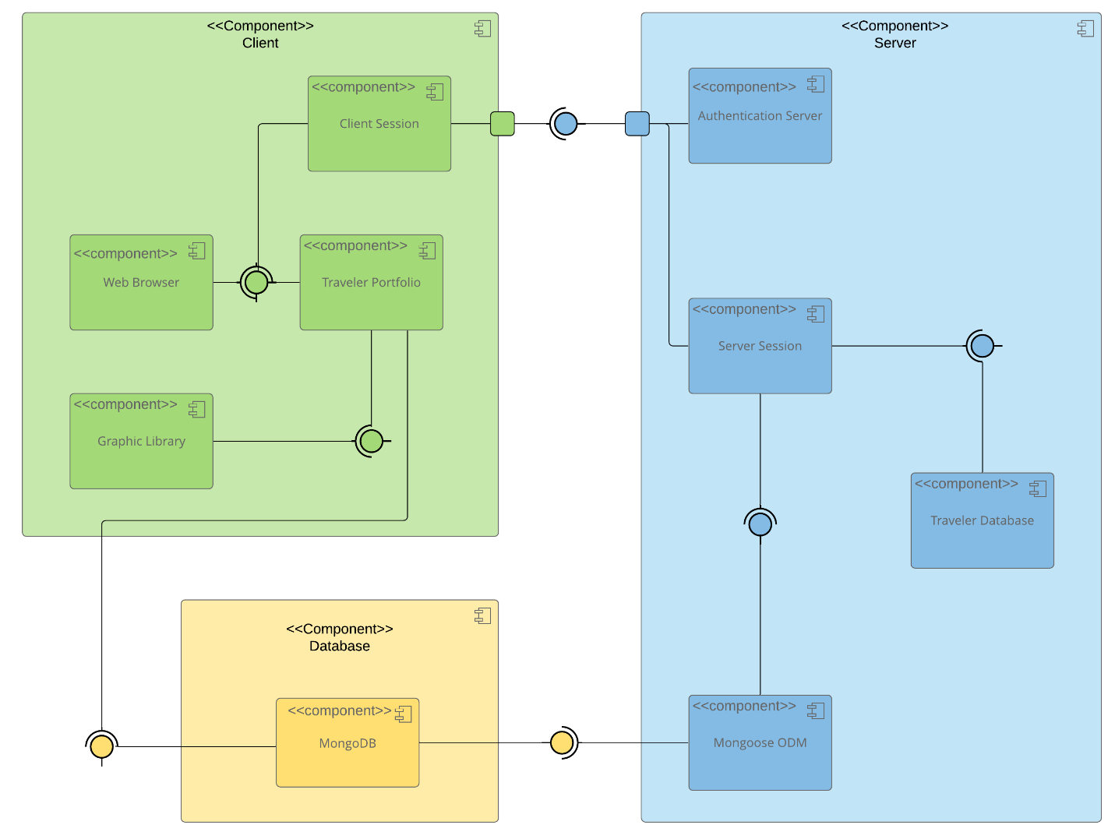

A text version of the component diagram is available: CS 465 Full Stack Component Diagram Text Version.

Our Travlr Getaways application follows a multi-tier client-server architecture. This will have three primary layers that separate specific concerns.

Database Tier: MongoDB will power the persistent data store that securely houses traveler information, booking details, and all administrative records.

Server Tier: Incoming data will be validated via Mongoose ODM (Object Data Modeling), which will structure the data via persistence operations. Anchoring the backend environment with Node.js/Express allows for utilizing an Authentication Server with a Server Session manger to handle secure requests.

Client Tier: Web browsers will host the Client Session and the Traveler Portfolio; they will use a Graphic Library for rendering dynamic views and user interactions handling. Communication from this tier is outward via interfaces to authenticate and fetch data from the server tier.

Component Relationships:
The component interaction will be thoroughly defined required and provided interfaces. The client-side portfolio will use secure server sessions to initiate requests. Mongoose ODM will translate application logic into queries for the MongoDB database. This will ensure a modular, scalable architecture from end to end.

Sequence Diagram

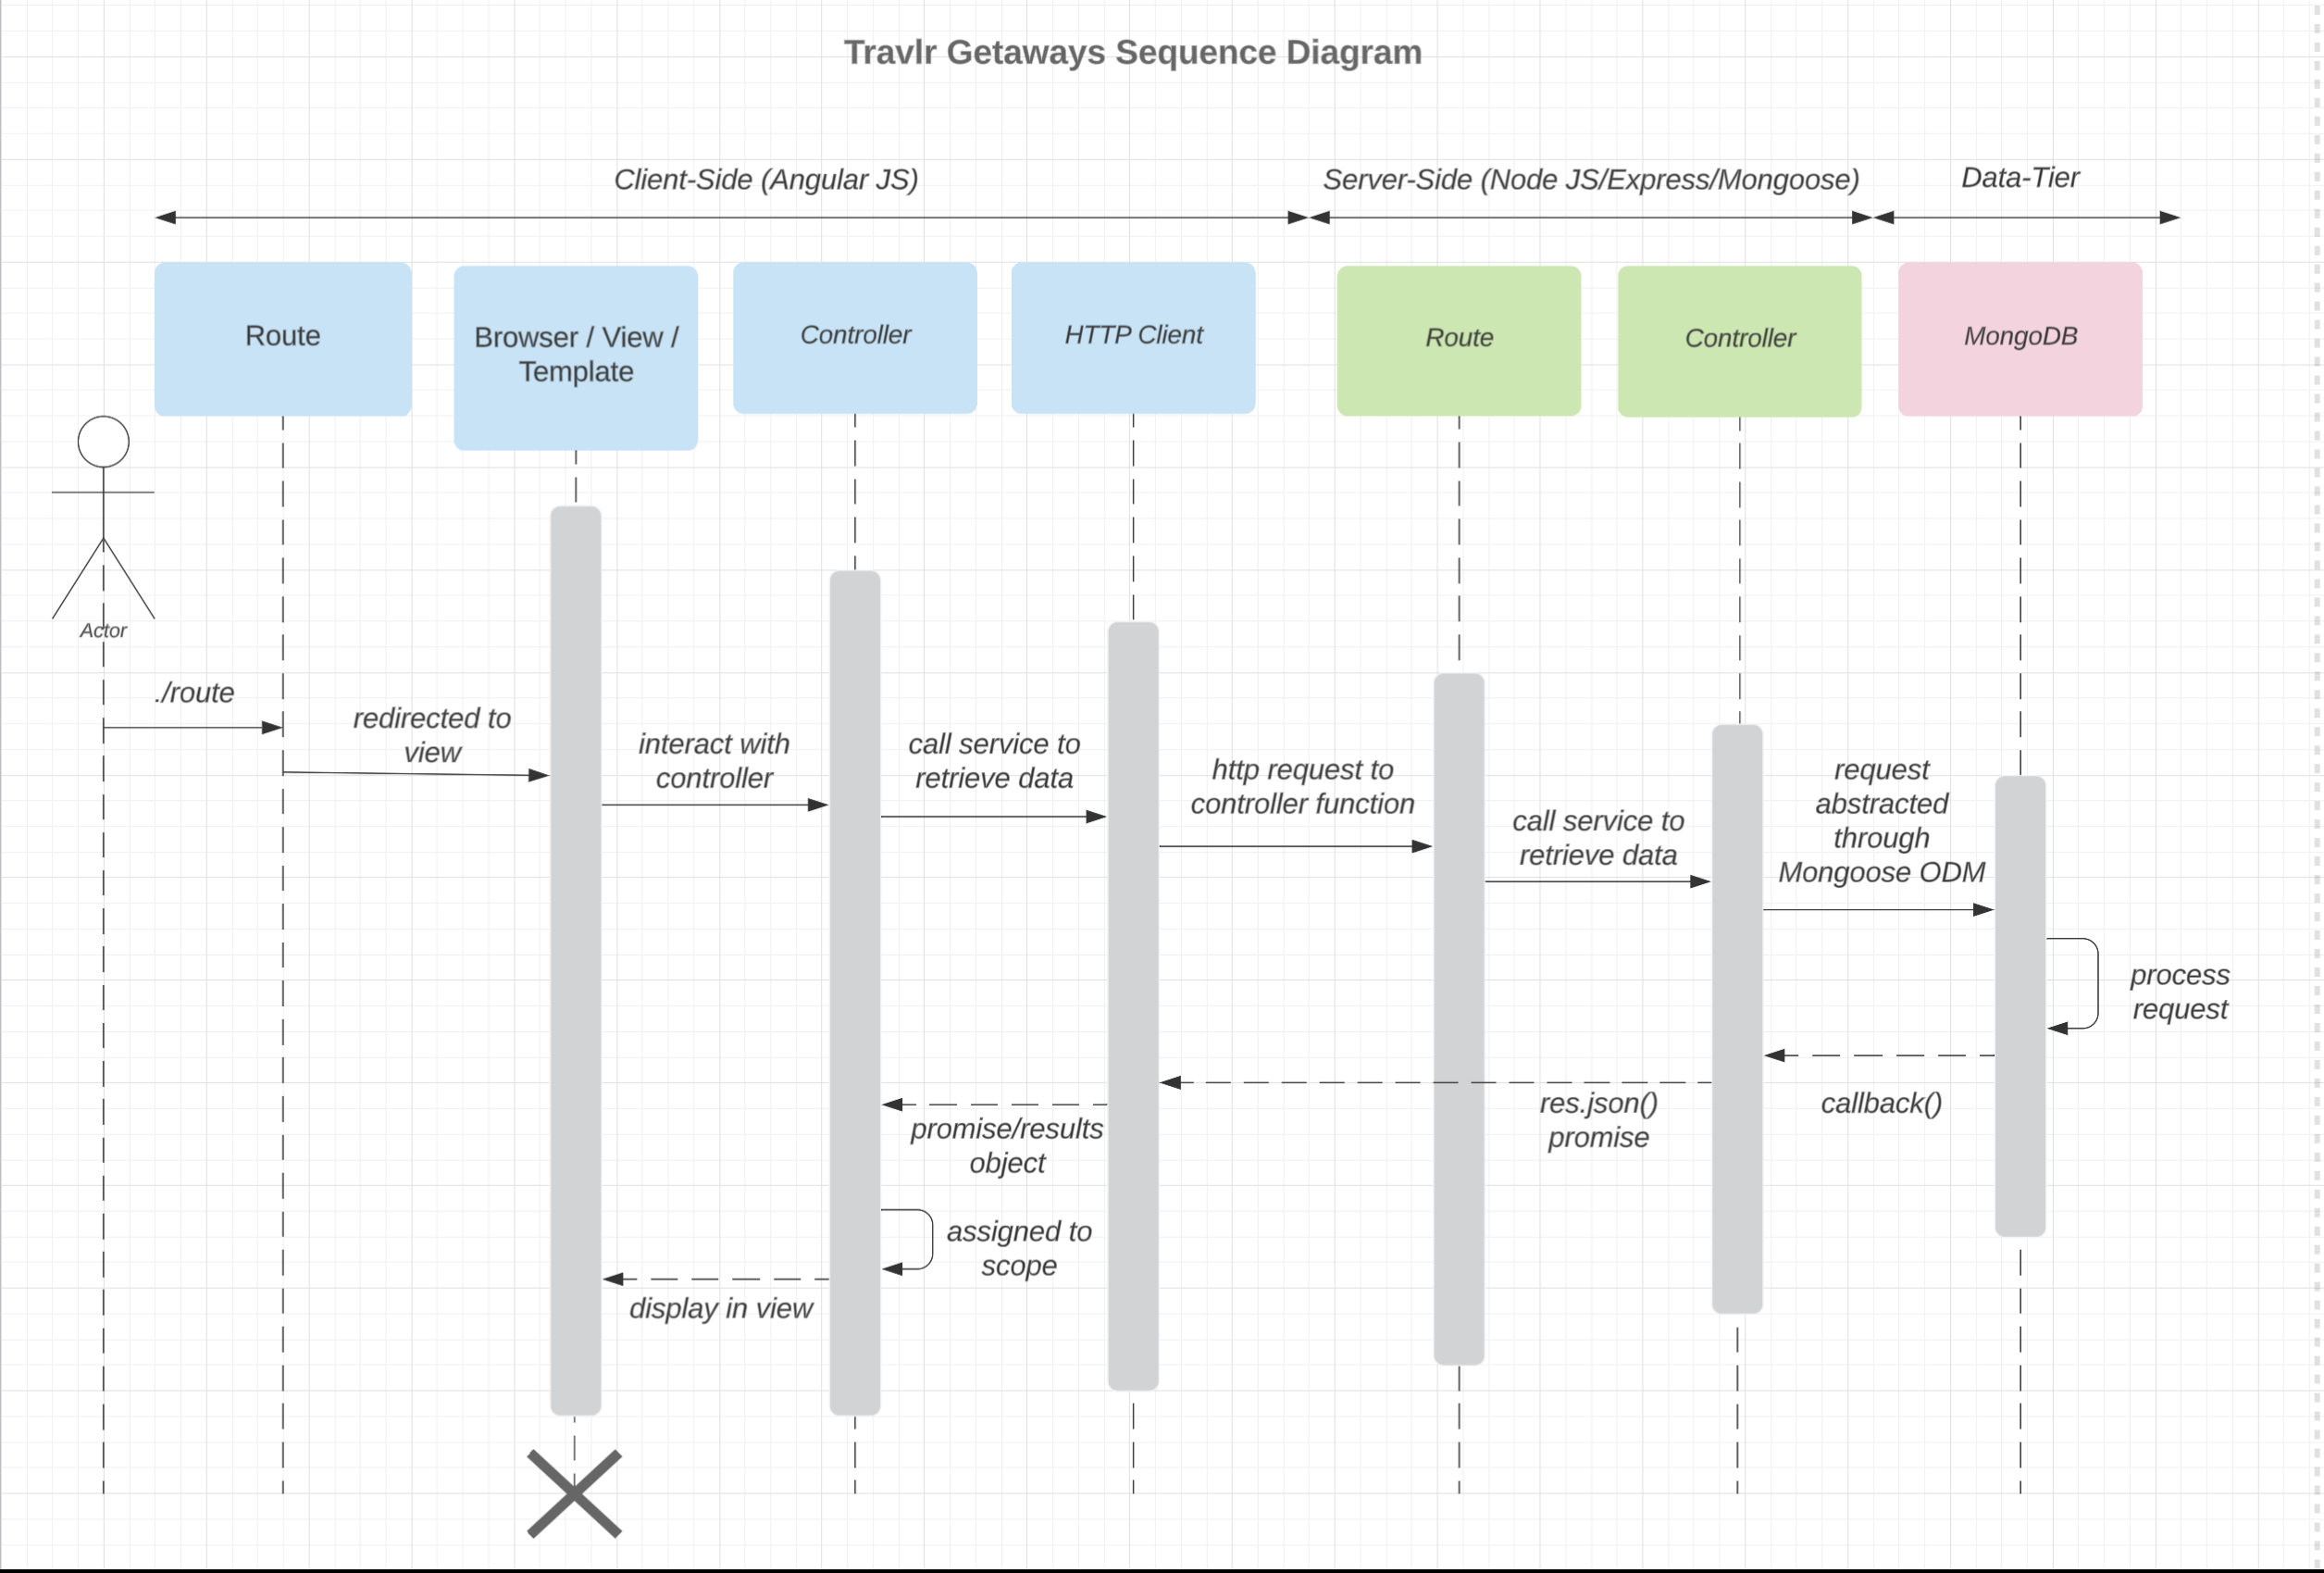

Sequence Diagram Description

Illustrated above is the flow of logic and data as it gets transmitted across multi-tier layers of architecture. The diagram captures critical interactions for the Travlr Getaways web application such as authentication, trip data retrieval, and administrator management.

- Client-Side Initiation Request: The process begins with an actor interacting with the client layer or the front-end web application via the browser Route, it appropriately redirects to the Browser / View / Template. Interactions from the user trigger the client-side Controller, which will leverage the HTTP Client to communicate outbound requests across the network.

- Sign-In and Trip Interaction Handling: Upon initiating a Sign In action or requesting a list of Trips, the client-side controller packages the request and sends an HTTP call to the server-side tier.

- Server-Side Processing & Admin Interactions: When completing Admin interaction for updating or creating trip listings the requests arrive at the backend server Route. The Route will then delegate execution to appropriate Controller functions. The controller will handle business logic and interface with Mongoose ODM for translation of application operations into structured database queries.

- Database Persistence & Response: Queries will reach the persistent MongoDB data tier and be processed. Once the query data is retrieved or updated, a JSON response will travel back through the sequence flow. The client-side application will then assign results to the view scope, and dynamically update the interface for a seamless completion of the transaction.

Class Diagram

Class Diagram Description

When looking at the class diagram for Travlr Getaways illustrates how the JavaScript classes are organized to support travel planning, traveler information, and member management. The classes have specific responsibilities for the application; this allows for the information and functionality to be separated into manageable components.

The Travel_Agent class will coordinate arrangement for travel methods for the booking packages, hotels, flights, and cruises. The TripInfo class maintains the trip details, including travel dates, origins, and destinations which are essential. While the Itinerary class represents additional travel information such as total price, distance, and stopovers.
Then the FlightInfo, HotelInfo, and CruiseInfo classes will contain specific information about the travel services offered. The classes will associate with FlightBooking, HotelBooking, CruiseBooking classes, which provide methods for accessing their respective booking information.

Traveler and membership information is represented through the TravellerInfo, MemberAccount, and Membership_Admin classes. These classes are made to support traveler details, membership status, reward points, and membership validation organization.

The illustrated relationships in the diagram should demonstrate how the different classes interact to support the booking process. The separation of the responsibilities allows for the application design to maintainable, organized, and allow for expansion opportunities in the future.

API Endpoints

Method | Purpose | URL | Notes
GET | Retrieves a list of all available trips. | /api/trips | Calls the tripsList controller function. Queries the MongoDB database using Mongoose and returns trip records in JSON format with HTTP status 200 upon success.
GET | Retrieve a specific trip based on its unique trip code. | /api/trips/:tripCode | Calls the tripsFindByCode controller function. Uses the tripcode parameter to search the MongoDB database and returns matching trip records in JSON format with HTTP status 200 upon success.

The User Interface

The User Interface

Angular and Express Project Structure

The Angular project uses a single-page application (SPA) structure that organizes the application into components, services, routes, and templates. Angular handles the administrative interface and allows users to interact with trip information without reloading the entire webpage. In comparison, the Express project uses a server-side structure with routes, controllers, and Handlebars (HBS) templates to display information to customers. Express handles requests and renders webpages, while Angular provides a more interactive experience through dynamic content updates.

The SPA provides additional functionality compared to a traditional web application. Administrators can view, add, and edit trip information directly through the interface. Angular updates the displayed content without requiring a complete page refresh, making the application more responsive and easier to navigate.

Testing the SPA and API

Testing involved running the Express server, MongoDB database, and Angular application to verify communication between the frontend and backend. The GET requests were tested by loading the trip list and confirming that the application retrieved and displayed the correct trip information from the database.

The PUT functionality was tested by selecting an existing trip, opening the Edit screen, changing the trip details, and submitting the updated information. After saving the changes, the trip information was checked to verify that the database had been updated successfully.

Additional testing included confirming that the administrative login worked, navigating between screens, and checking that trip information remained updated after refreshing the application. These tests helped verify that the Angular SPA communicated correctly with the Express API and MongoDB database.

